EGR326 Lab8 F24

Seven Segment 8 Character LED display

LED displays are commonly used as alphanumeric indicators on test equipment cockpits, and most importantly, incorporated into the Delorean dashboard in “Back to the Future”.

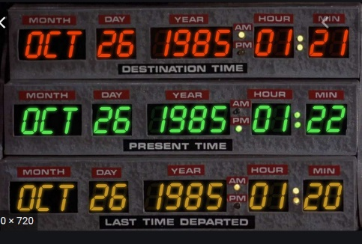

7 Segment displays come in many flavors- common cathode, common anode, etc. All of these require multiple GPIO pins/digit. Although the LED display in your kit has a limited character library, it will allow you to program 8 digits, using only 3 signal lines, along with power and ground. It can even be expanded to multiple 8 character displays, with no additional pins.

The driver for the display is the MAX7219. You can find the datasheet on Blackboard. You will be using the SPI bus to connect and control your display. If you study the datasheet carefully, you will notice several requirements when setting up your device.

1. You must power the device from 5V
2. Minimum “high” voltage = 3.5V. So this would indicate that 3.3V SPI signals will not work. You should debug your circuit level shifting your signals to 5.0V
3. The connections from your STM are shown below:

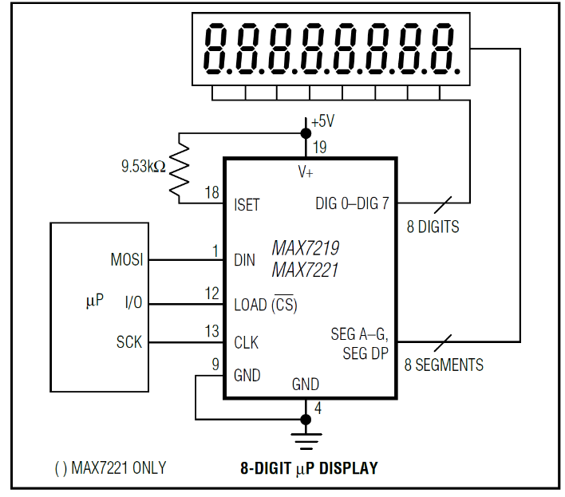You can pick your SPI port. There are 4 available on the STM32F446

The “I/O” pin shown should be substituted with a GPIO pin and not controlled by the SPI controller.

1. When programming the LED display, the following steps should be followed:
   1. Data must be sent in 16 bit chunks - 8 bits of “instruction” and 8 bits of data. The instructions are listed as addresses on page 7 of the datasheet You can send two bursts of data while holding the CS low. Data will be shifted into the MAX7219 on the rising edge of CS- which should occur after the last bit has been transmitted.
   2. The first instruction/data set to be sent should define the decode mode
   3. The Second instruction/data combo should define the Intensity
   4. The Third Instruction/data should determine the scan limit (number of digits to display)
   5. Finally, the last instruction/data, before displaying data, should disable “shutdown”
2. After the initialization of step 4 is complete, the display can be controlled by writing an address and data (one LED digit at a time). Pay attention that the clock speed is limited to 10MHz-
3. Interface 3 pushbuttons and the 7seg display to your STM. Using one of the STMs timer, configure the following:
4. Update the first 2 digits every second (up to 15 seconds)
5. Update the 4th and 5th digit to update 10 times/second.
6. Update the 7th and 8th digit to also update 10 time/second (synchronized to the 4th and 5th digit)

One pushbutton will start the count. The two other pushbuttons control either the 4th and 5th digits or 7th and 8th digits respectively indicating the resulting count of both players.

After the count is started, pushing either of the two remaining buttons will stop the respective counts. This is used to test the response times of two individuals at once.

Demonstrate this “response” activity to your instructor

Your report should be submitted on Blackboard and should contain:

1. a description of your complete schematic
2. a copy of the test program
3. a description of how it works (along with a software flow diagram)